**Introduction**

This project aims to analyze data on precipitation in Seattle WA and New York City NY from January 1, 2020 to January 1, 2024 to determine which city gets more rainfall. The data I will be using comes from the National Centers for Environmental Information online search tool which can be accessed via this link, <https://www.ncei.noaa.gov/cdo-web/search?datasetid=GHCND>.

The data contains various measures of climate collected from several weather stations across the US however for this project, I’ll be focusing on Seattle and New York City. I began by cleaning the data, I removed all unnecessary columns and chose one station from each city to get an equal amount of data. I chose JFK Airport for NYC and Seatac Airport for Seattle as the stations of choice because they were both airports which meant that they likely had good high-quality data since monitoring weather information is very important for the safety of airplanes. I did encounter some null values for precipitation in the Seatac dataset so I filled those in with the average value of precipitation during the same month of the observation. In the end, I ended up with a dataset that I deemed fit for analysis, it contained three columns: the date, the city, and the amount of precipitation on that day measured in inches.

**Visualization One Visualization Two**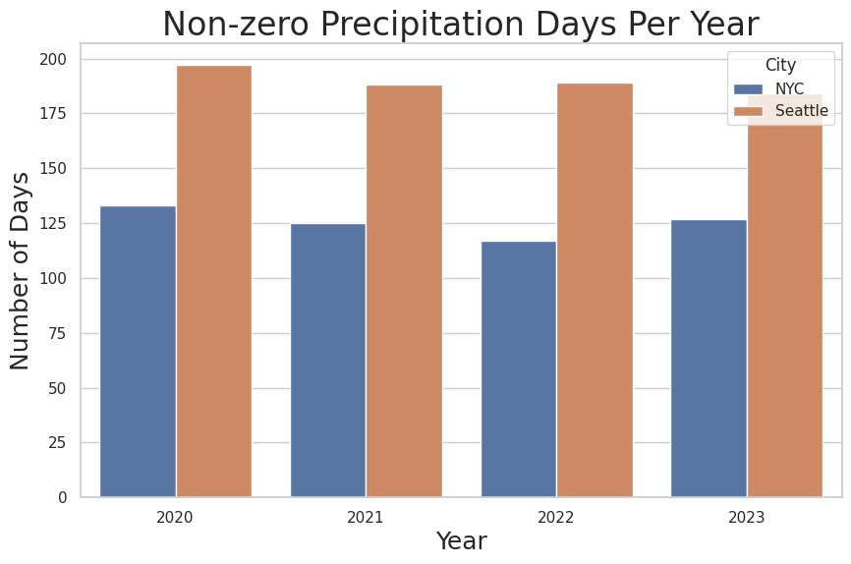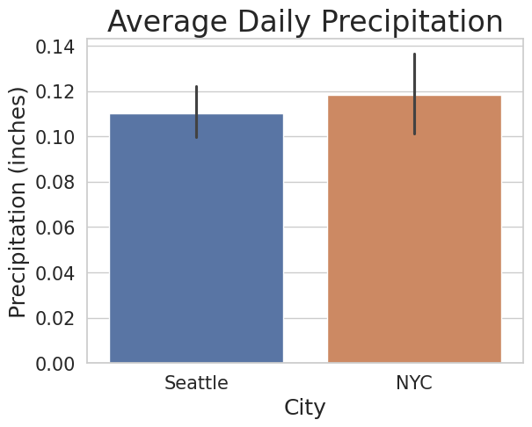

The first visualization is a bar graph showing the number of days that received rain in each city separated by the year. From this visualization, we see that in all four years, Seattle had significantly more rainy days than in NYC. Roughly speaking, the number of rainy days in Seattle is 1.5 times greater than the number of rainy days in NYC.

The second visualization is a simple bar graph showing each city's average daily precipitation across all four years with a line showing the variation. We can see that NYC has a higher average with more variation than Seattle.

**Visualization Three**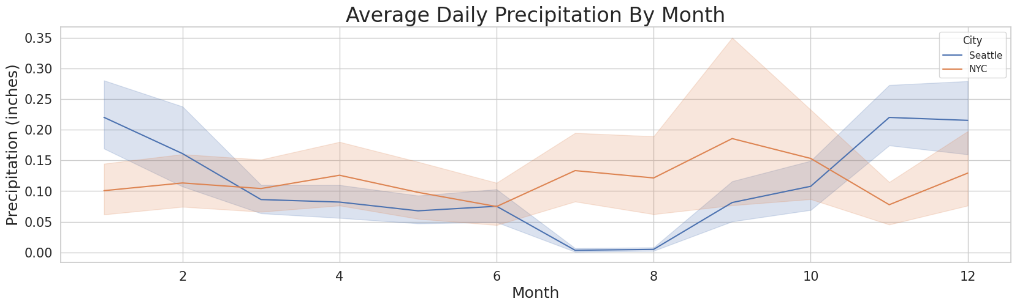

In the third visualization, I calculated the average precipitation across all four years and grouped them by month. From this graph, we can see that from around October to March, Seattle receives more rain daily than NYC on average, but on every other month, NYC receives more rain than Seattle. Also looking at the error bars, we see that NYC has a wider distribution of rain while Seattle’s rainfall is less sporadic.

**Conclusion:**

To determine whether NYC or Seattle rains more depends on personal preference. If you prefer to avoid instances of rain no matter how small, I would say that NYC would be your preferred destination as it rains about 75 days less than it does in Seattle. However, if you prefer to avoid days of torrential downpours and aren’t too bothered by light showers, the data suggests that you move to Seattle because on average it rains less in terms of inches of rain and when it does rain, the amount of rain is more predictable in Seattle than NYC. Based on this analysis, you’re able to decide whether Seattle or NYC’s climate best suits your lifestyle.